**Use Dynamic Traffic Network Loading to Understand Traffic Congestion Propagation**

**(Understand Theoretical Basics of Dynamic Traffic Network Assignment and Simulation: Part II)**

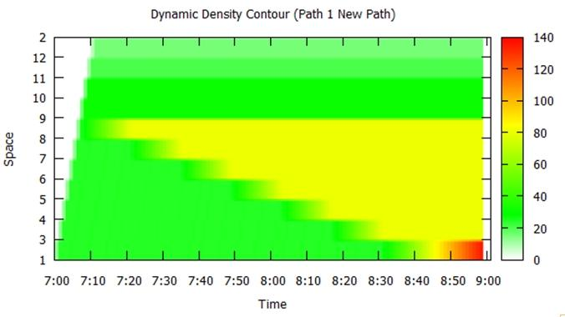

**Prepared by**: Jiangtao Liu, Xuesong Zhou, Jinjin Tang, Jeffrey Taylor

**Goal:**

(1) Understand major input and output data for a dynamic network loading program;

(2) Identify bottlenecks and model congestion propagation;

(3) Calculate traffic states through different computational approaches.

**Contents:**

Introduction to Dynamic Network Loading: Input and Output

Overview of 3-corridor network and experiments

(1) Network

1) Check the property of the network

2) Calculate travel time of three paths and find links with minimum capacity

(2) OD demand matrix

(3) Traffic States as a result of demand-supply interactions

(I) Network Level Text Display

(II) Path Level Dynamic Contour Plot

(III) Link Level MOE Display

(IV) Time-dependent Link MOE Visualization

(V) Introduction to two methods for traffic state estimation

(4) Simulation setup

Case1: demand = supply (multiplier = 1.0)

(1) DTALite (KW SimulationModel)

(2) Graphical Method

Case2: demand > supply (multiplier=1.2)

(1) DTALite (KW Simulation Model)

(2) Graphical Method

Case3: demand > supply (multiplier = 1.3)

(1) DTALite (KW Simulation Model)

(2) Graphical Method

|  |  |
| --- | --- |
| Fig.1. The process of dynamic network loading | 1. The **basic data input** for a dynamic network loading program (g) includes time-dependent origin-destination demand (a) and the traffic network (b) with road capacity constraints on links and nodes.  2. **Activity locations** (c) describe a zone-to-node mapping between OD demand matrix (a) and the traffic network (b). The vehicles generation process (d) determines specific origin, destination, and departure time of agents/vehicles, which leads to an agent attribute database (i), to be iteratively updated throughout the simulation process.  3. Through calculating the **dynamic travel time** of all links (free-flow travel time is used at first iteration), corresponding to element (e), the **route choice model** (f) embeds a standard time-dependent least-cost path algorithm (k) to generate paths for all agents.  4. The core **dynamic network loading program** (g) loads previously generated agents on the traffic network for the entire planning horizon, which produces traffic data output (h) that describes time-varying traffic states at the link level, including traffic flow volume, traffic density, speed, travel time. The link-based traffic states (h) can be further processed to represent traffic congestion and propagation at the aggregated path level, as well as update the time-dependent travel time database (e).  5. At the following step within an **iterative assignment process**, the route choice module (f) will again recomputed the route selection for each agent using updated travel times (e), for another iteration of dynamic network loading (g), until the model is converged or reaches the maximum number of iterations.  6. The **pre-trip information and road toll charges** ( j) can also affect travelers’ route choice behavior by changing generalized link travel times . **Traffic incidents and work zones** (l) are considered as capacity reduction events which are fed into the traffic network loading program (g). |

# **Introduction to Dynamic Network Loading: Input and Output**

A dynamic traffic assignment program includes two major components: dynamic network loading and traveler route assignment. In this learning document, we focus on the first dynamic network-loading module using single assignment iteration. Its general process is shown below

**Methods:**

This document utilizes two methods to compute traffic states under different levels of traffic demand and the same bottleneck capacity.

* Analytical model and graphical solution method
* Newell’s simplified Kinematic Wave Model (Newell, 1993), which is implemented in the DTALite simulation engine.

By systematically comparing results from those two methods, students are expected to verify and understand the demand-supply interaction mechanism of a dynamic network loading program. Doing this set of exercises could help students tackle more complicated topics, such as dynamic route choice and traffic management scenario evaluation.

**Overview of 3-corridor network and experiments:**

The demand time period in this experiment covers from 7:00 am to 9:00 am, and the hypothetic traffic network is shown in Fig. 2. To understand a dynamic network loading data set, we will go over the following data elements first:

## (1) Network

This network includes 40 nodes, 55 links, 6 zones and 6 activity locations. There are two major zones: origin zone 1 and destination zone 2, which are associated with three major paths (path 1, path 2, and path 3) as shown in Fig. 2.

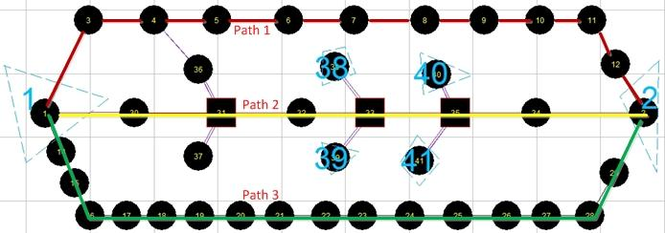

Fig. 2. Layout of 3-corridor traffic network

### 

### 1) Check the property of the network

Please first use NeXTA to find the number of nodes, links, zones, and activity locations. The properties of the network are shown in Table 1.

Table 1. Properties of traffic network

|  |  |  |  |  |
| --- | --- | --- | --- | --- |
| **File No.** | **GIS Layer** | **Associated Data File** | **Associated Menu for Data Editing** | **Important Attributes** |
| 1 | Node | [input_node.csv](https://docs.google.com/spreadsheet/ccc?key=0AuAme-zXfj7pdDdrTWlVd2FoSzZyZGo0LTRhdm9lMEE#gid=0) | Project->Network Data-> Node | node coordinate, control type |
| 2 | Link | [input_link.csv](https://docs.google.com/spreadsheet/ccc?key=0AuAme-zXfj7pdDlXTVh3Y25GcFpVMTZGcXVUeGx2eXc#gid=0) | Project->Network Data-> Link | from node, to node, speed limit -> free-flow travel time, capacity, number of lanes |
| 3 | Zone | [input_zone.csv](https://docs.google.com/spreadsheet/ccc?key=0AuAme-zXfj7pdGtnMjNrSW1kRzZuMVV2UEFOZlYzZmc#gid=0) | Project->Network Data-> Zone | zone definition for OD demand |
| 4 | Activity Location (similar to centroid) | [input_activity_location.csv](https://docs.google.com/spreadsheet/ccc?key=0AuAme-zXfj7pdHh6ZzhsZXZseWtzQTZoZEpJQm5paXc#gid=0) | Project->Network Data-> Activity Location | mapping from zone number to nodes as origin or destination |
| 5 | OD demand matrix | [input_demand_meta_data.csv](https://docs.google.com/spreadsheet/ccc?key=0AuAme-zXfj7pdFN5cWpFdjI1aUp1SkNFVUUtYlJhS2c#gid=0)  [input_demand.csv](https://docs.google.com/spreadsheet/ccc?key=0AuAme-zXfj7pdGFNeVlmNmVQbUY2QXBEa2thMmxRR1E#gid=0) | Project-> Demand Meta Database | # of trips from zone i to zone j |
| 6 | Traffic simulation setup | [input_scenario_settings.csv](https://docs.google.com/spreadsheet/ccc?key=0AuAme-zXfj7pdHhhdXdlY18wYjBhenFSa3JHVUREMXc#gid=0) | Project-> Assignment/Simulation Setting | # of iterations, traffic models, traffic assignment method… |
| 7 | Generated Vehicle Data | [output_agent.csv](https://docs.google.com/spreadsheet/ccc?key=0AuAme-zXfj7pdGQ5dE4yTFdvX2hKY2Exb2s1NFhCclE#gid=0) | --- | Agent ID, Arrival time, departure time… |
| 8 | Traffic States | [output_LinkTDMOE.csv](https://docs.google.com/spreadsheet/ccc?key=0AuAme-zXfj7pdGZwUmt5UDVzUEFrUzF5MmdUS21NYnc#gid=0) | --- | Travel time, speed, density… |

**Link properties:**

To check the link properties in NeXTA, please follow the steps below for link 8->9 as an example, shown in Fig. 4.

Select the “Link” in the GIS layers panel, then right click to choose “View Link Properties for Selected Link”.

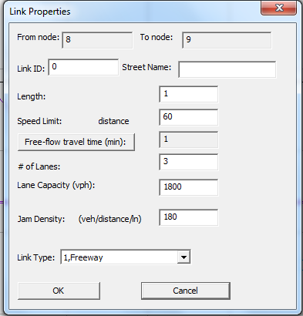

Fig. 3. Properties of link 8->9

**Node and link tables:**

To check node and link tables, please follow the steps in Fig. 4.

|  |  |
| --- | --- |
| Fig.4. Properties of link 8->9 | STEPS  **Step 1**: click the “Project” in menu bar.  **Step 2**: click “1.Network Data”.  **Step 3**: click “node”, “link”, “zone”, etc. in the tag |

**Problem 1 (for students):** 

1. Which node is defined as the origin node of zone 1? (check input_activity_location file)
2. Which node is defined as the destination node of zone 2? (check input_activity_location file)
3. How many trips are loaded from 7AM to 8AM? (Check input_demand_meta_data file and associated demand file.)

### 2) Calculate travel time of three paths and find links with minimum capacity

In this experiment, we will examine major features of the dynamic network-loading module in DTALite by using a single assignment iteration. In DTALite’s first iteration, all drivers use the first path (which is the minimum travel time path), calculated based on a free-flow condition. We first go over two approaches for calculating the travel time of a path.

**(i) Manual calculation by using data from input_link.csv**

The data from input_link.csv for calculation of path 1 is shown in table 2. Students can also calculate path travel times on paths 2 and 3

Table 2. Link attributes for calculating the travel time of path 1

|  |  |  |  |  |
| --- | --- | --- | --- | --- |
| **No.** | **Link(From node-> to Node)** | **Distance (mile)** | **Free-flow travel time(min)** | **Link capacity (veh/h)** |
| 1 | 1->3 | 1 | 1 | 5400 |
| 2 | 3->4 | 1 | 1 | 5400 |
| 3 | 4->5 | 1 | 1 | 5400 |
| 4 | 5->6 | 1 | 1 | 5400 |
| 5 | 6->7 | 1 | 1 | 5400 |
| 6 | 7->8 | 1 | 1 | 5400 |
| 7 | 8->9 | 1 | 1 | 5400 |
| 8 | 9->10 | 1 | 1 | 3600 |
| 9 | 10->11 | 1 | 1 | 3600 |
| 10 | 11->12 | 1 | 1 | 5400 |
| 11 | 12->2 | 1 | 1 | 7200 |
| Subtotal | --- | 11 | 11 | --- |

In Table 2, based on the capacity of links, the bottleneck is link 9->10 and link 10->11. It should be remarked here, DTALite assumes homogeneous link capacity (which means that the capacity of any sections of the link is equal), so the capacity value puts a constraint on both incoming flow and outgoing flow of a link, such as, the link shown in Fig. 5.

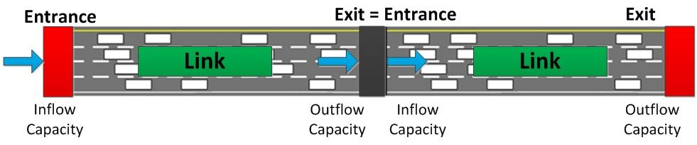

**Fig. 5. Capacity analysis of one link**

For link 8->9, although its (outgoing flow) capacity is 5400 vehicles per hour per link, its actual number of output flow volume being discharged also depends on the inflow capacity of its next link, link 9->10, with a capacity of 3600 vehicles per hour per link. Thus, when the demand of link 8->9 is greater than 3600 per hour, at its exit point (i.e. the downstream node 9), a queue will be formed as a result of traffic congestion, and will be propagated to other upstream links. Table 3 summarizes the travel times on three paths.

**Table 3. Travel time and travel distance of three paths**

|  |  |  |  |  |  |
| --- | --- | --- | --- | --- | --- |
| **Path** | **Node sequence** | **# of links** | **Travel time (min)** | **Travel Distance (mile)** | **Bottleneck** |
| Path 1 (Major Freeway) | 1->3->4...-> 12->2 | 11 | 11 | 11 | Link 9->10, Link 10->11 |
| Path 2 (Alternative Arterial corridor) | 1->30->31...-> 34->2 | 7 | 12 | 8 |  |
| Path 3 (Alternative Freeway) | 1->14->15...-> 29->2 | 17 | 17 | 17 |  |

The free-flow travel times of path 1, path 2, and path 3 are 11 min, 12 min, and 17 min, respectively. Since path 1 has the least travel time, it will be first chosen when the OD demand is sufficiently small. In the following session, we will focus on path 1.

**Problem 2 (for students)** 

1. Which path will be selected at the first iteration?
2. Find links with minimum capacity along three paths. Show the upstream node and downstream node numbers of those links and the hourly capacity values. Please use an image to highlight these links in the traffic network.
3. What is the expected speed on link 8->9, if the demand is 5400 vehicles per hour, and all vehicles use the first path?

**(ii) Obtain travel time of paths through NeXTA**

The method of selecting a path is shown in Fig. 6. The travel time of path 2 and path 3 can be obtained, similarly.

|  |  |
| --- | --- |
| Fig.6. Path list dialog | STEPS  **Step 1**: Select the “path” layer in the GIS layers panel  **Step 2**: Click on node 1-> right click menu to choose “Direction from here”  **Step 3**: Click node 2-> right click menu to choose “Direction to here”  **Step 4**: Select any node (e.g. node 6) of the path 1-> right click to choose “Add Intermediate Destination here”.  **Step 5**: To view the traffic states of selected path, click on the “Path” button in the MOE bar |

## (2) OD demand matrix

For checking the OD demand, there are two methods:

* Method 1: check the input_demand_meta_data.csv and input_demand.csv in table 1;
* Method 2: through the NeXTA’s interface: the result is shown in Fig.7.

|  |  |
| --- | --- |
| Fig.7.OD demand matrix | STEPS  **Step 1**: Click on **“Project”** in the menu bar  **Step 2**: **“2 Demand Meta Database”**  **Step 3**: Click any row of **“1. Demand File List”**.  **Step 4**: The corresponding OD demand will be shown in the “3.OD Demand Matrix”. |

## 

## (3) Traffic States as a result of demand-supply interactions

NeXTA provides a number of visualization interfaces for checking the traffic states such as density and volume.

### (I) Network Level Text Display

Please follow the steps in Fig. 8 to view traffic states for all links in the network. For example, check the “Total Volume over Capacity Ratio”.

|  |  |
| --- | --- |
| Fig.8. Procedure of analyzing the bottleneck | STEPS  **Step 1**: Click on the “Config” button at the top of the GIS layers panel  **Step 2**:“Total Volume over Capacity Ratio” in “link text label”  **Step 3**: Slide the “time bar” to the simulation time at 7am to 9am  **Step 4**: View the volume over capacity of any links in the network. |

### 

### (II) Path Level Dynamic Contour Plot

Please follow the steps in Fig. 6 to define a path using NeXTA, and then plot “Density Contour”, “Speed Contour”, “V/C Contour”, shown in Fig.9.

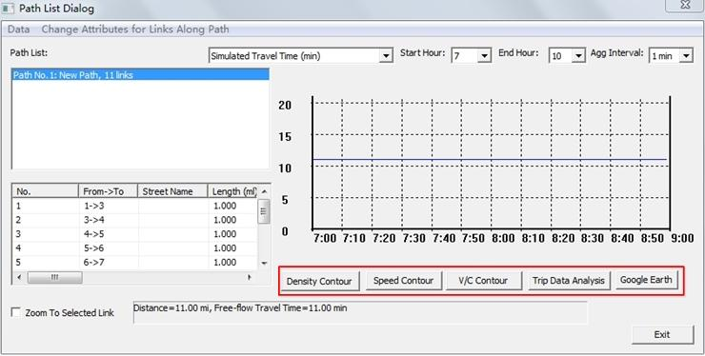

Fig.9. Path list dialog

### (III) Link Level MOE Display

Select the “Link performance” layer of the GIS layer panel and then click one link to see the. link MOE dialog shown in Fig.10.

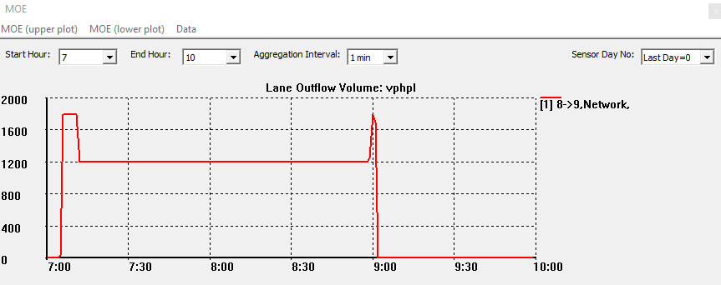

Fig.10. Interface of the MOE of link 8->9

Please click the “MOE (upper plot)” in the menu bar, and examine different traffic state variables shown in Fig.11. One can use the key combination “control +click” to select multiple links into the link MOE display.

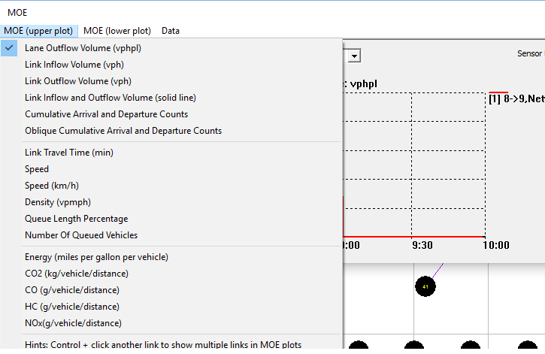

Fig.11. Detailed content of Link MOE

### (IV) Time-dependent Link MOE Visualization

Following the steps introduced in Lesson 1.1, one can also visualize traffic states using the tool bars shown in Fig.12.



Fig.12. Shortcut icons for traffic simulation and analysis

### (V) Introduction to two methods for traffic state estimation

Now we introduce two calculation methods for estimating traffic states in this document.

**(i) Graphical method**

Take the freeway on path 1 as an example. Its property is shown in the Fig.13, and the flow-density relationship for different lanes of links can be plotted in Fig.14.

|  |  |
| --- | --- |
| Fig.13. Properties of link | Fig.14. The flow-density relationship for different lanes of links |

**(ii) KW simulation model in DTALite**

Dr. Newell’s papers on kinematic wave modeling are

*A Simplified Theory of Kinematic Waves in Highway Traffic*, part 1, 2, 3, ( G.F.Newell, 1993 )

DTALite has implemented the simulation steps, and interested readers can find the source code at https://code.google.com/p/nexta/source/list).

The high-level overview of the three test cases in our experiment is shown in Fig.15.

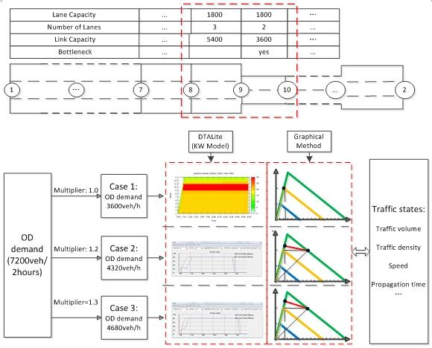

Fig.15. High-level overview of three testing cases

## (4) Simulation setup

Review “network data”, “demand data” and “traffic management scenarios”.

* : Clicking the button in the tool bar

The interface is shown in Fig.16.

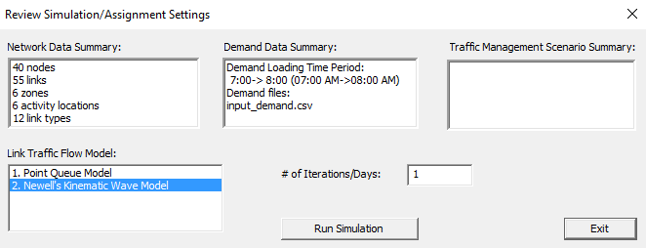

Fig.16. the interface of simulation settings

# 

# **Case 1: demand = supply (multiplier = 1.0)**

## (1) DTALite (KW SimulationModel)

**1)** Check the value of traffic demand

The traffic demand from origin zone 1 to destination zone 2 is 7200 vehicles in two hours.

* Method 1: “input_demand.csv” in the project folder.
* Method 2: through the NeXTA’s interface: the result is shown in Fig.17.

|  |  |
| --- | --- |
| Fig.17.OD demand matrix | STEPS  **Step 1**: Click on **“project”** in the menu bar  **Step 2**: **“2 Demand Meta Database”**  **Step 3**: Click any row of **“1. Demand File List”**.  **Step 4**: The corresponding OD demand will be shown in the “3.OD Demand Matrix”. |

**2)** Setup simulation settings

Please use the following simulation settings shown in Fig.18.

|  |  |
| --- | --- |
| Fig.18. The interface of settings for case 1 | * Link Traffic Flow Model: **Newell’s model+ Emissions Output** * Signal Control Representation: **Continuous Flow with Link Capacity Constraint** * Traffic Assignment Method: **0.** **Method of Successive Average** or **1.Fixed Switching Rate** * # of Iterations/Days: **1** |

**3)** View the result of simulation and analyze traffic states

**3.1)** Traffic variable: “Total Volume over Capacity Ratio”

**(i)** View the simulation result: “Total Volume over Capacity Ratio”

The procedure and result are shown in Fig.19.

|  |  |
| --- | --- |
| Fig.19. The procedure of analyzing the bottleneck | STEPS  **Step 1**: Click on the “config” button at the top of the GIS layers panel  **Step 2**:“Total Volume over Capacity Ratio” in “link text label”  **Step 3**: Slide the “time clock” to the simulation time at 7am to 9am  **Step 4**: View the volume over capacity of any links in the network. |

**(ii)** Analyze the simulation result: “Total Volume over Capacity Ratio”

Question: Why Link 9->10 and link 10->11 are easy to be bottleneck? It is due to its capacity and traffic demand. In this case, the path 1 is only chosen. The capacity of the link is 3600 per hour, the OD demand is 7200, and the simulation time is 2 hours, so its volume/capacity is 1.

**3.2)** View the traffic states of one path

**(i)** View the simulation result

Through the operation mentioned above, the traffic states of path 1 can be viewed in Fig.20.

|  |  |
| --- | --- |
| Fig.20. The interface of path analysis | STEPS  **Step 1**: Select the “path” layer in the GIS layers panel  **Step 2**: Click on node 1-> right click menu to choose “Direction from here”  **Step 3**: Click node 2-> right click menu to choose “Direction to here”  **Step 4**: Select any node (e.g. node 8) of the path 1-> right click to choose “Add Intermediate Destination here”.  **Step 5**: To view the traffic states of selected path, click on the “Path” button in the MOE bar |

Then, click on the “Density Contour”, “Speed Contour”, and “V/C Contour” to analyze the details of this traffic assignment. The assumption is that you have installed the ***gnuplot*** software at<http://sourceforge.net/projects/gnuplot/files/>.

**(ii)** Analyze the simulation result:

In this case, the density contour is shown in Fig.21. Similarly, other analyses can also be displayed easily.

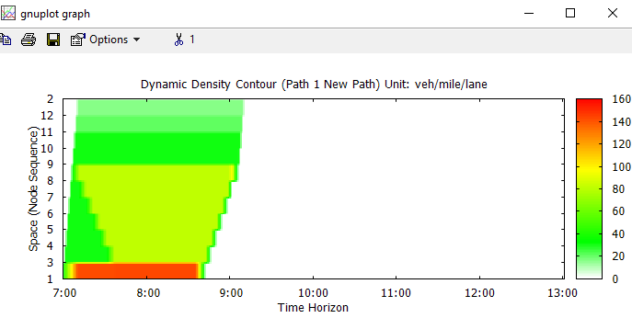

Fig.21. The plot of dynamic density of path 1

From this figure, link 9->10 and link 10->11 has a high density, which is consistent with the above “Total Volume over Capacity Ratio”.

**3.3)** View link MOE of bottleneck links

**Problem 3 (for students)**  

Please show the traffic density, speed and link and lane-based volume time series plots for links 8->9 and link 9->10. Explain why the density on link 8->9 is 20 vehicles per mile per lane, shown in Fig. 24.

**Problem 4 (for students)** 

In order to have detailed data extracted from the simulation results, please click on Menu->Data ->Export Link MOE to CSV File.

Please plot the flow-density points in the Q-K relationship figure for links 8->9 and 9->10.

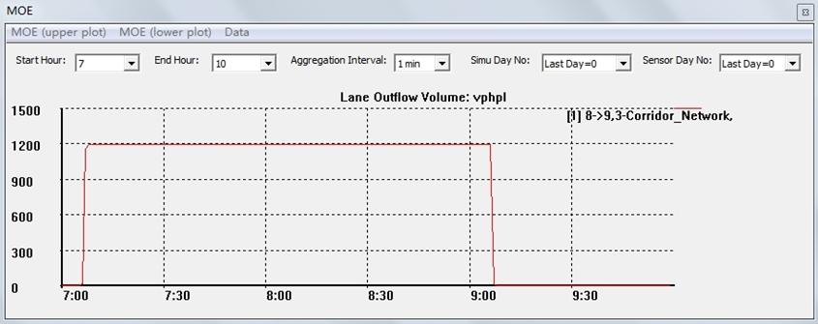

Fig.22. Simulated lane volume of link 8->9

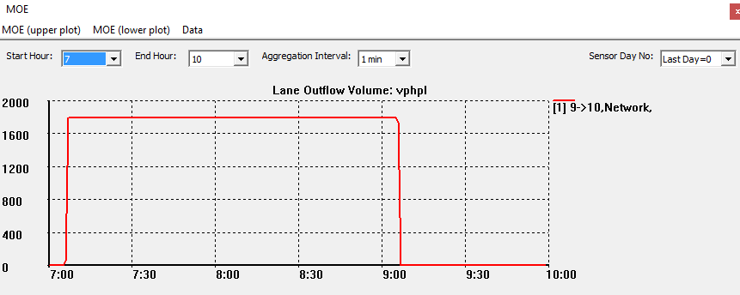

Fig.23. Simulated speed of link 8->9

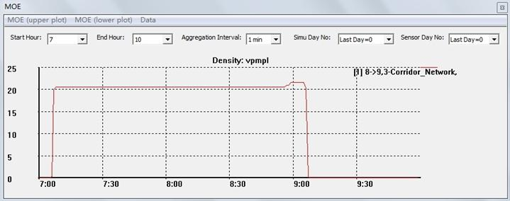

Fig.24. Simulated density of link 8->9

## 

## (2) Graphical Method

In order to ensure DTALite provides results from the analytical method, we now examine link 8->9 and link 9->10. Recall that, link 8->9 has three lanes and link 9->10 has two lanes. One can derive their traffic states using the graphical method shown in Fig.25. and Fig.26.

|  |  |
| --- | --- |
| Fig.25. The flow-density relationship for different states of links | U: interface between two different traffic states.  State O: there is no traffic flow  State A: the demand traffic enter the link 8->9  State C: the steady traffic state of link 9->10 |
| Fig.26. Vehicles’ trajectory in space-time diagram | **Speed:** The speed of link 8->9 and link 9->10 is the free flow speed, 60 mph, because the demand is equal to the capacity for the two links.  **Density:** Link 8->9 is always at the state A and link 9->10 is at the state C, so its density is 60 vpmpl(link) for the both links. Meanwhile, about the density of each lane, link 8->9 is 20 vpmpl(lane) and link 9->10 is 30 vpmpl(lane).  **Propagation time duration**: N/A |

# **Case2: demand > supply (multiplier=1.2)**

## (1) DTALite (KW Simulation Model)

When the demand multiplier is 1.2, the hourly OD demand is 0.5*7200*1.2 (4320). The limit capacity of the path 1 is 3600, so now the demand is slightly higher than the path capacity. As a result, a traffic congestion is formed and further propagted to the upstream corridor. The procedures are

1. go to input_demad_data_list
2. Change the loading multiplier to 1.2 in the excel sheet

) Check the “Total Volume over Capacity Ratio” first to locate the bottlenecks, shown in Fig.27, done like case 1.

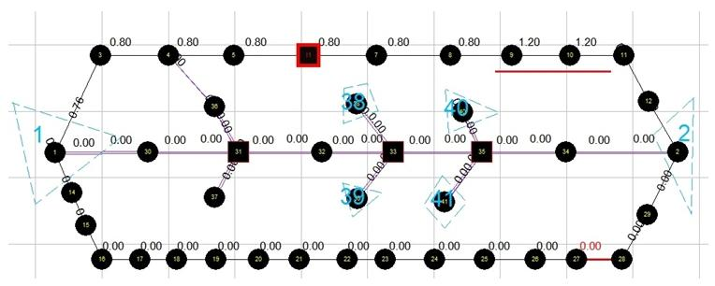

Fig.27. Total volume over capacity ratio of case 2

3) View its density contour shown in Fig.28.



Fig.28. Density contour of path 1 in case 2

Indicated by the above figure, traffic congestion starts from link 8->9, and then propagates back to upstream links. Then the traffic jam reaches the starting link 1->3 (without further space to accommodate the congestion), leading to continuously increasing density.

3) Check the speed, density, and propagation time of link 8->9 from the “Link MOE” dialog, shown in Fig.29. and Fig.30, respectively.

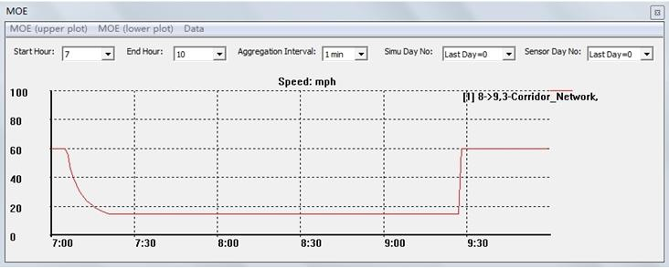

Fig.29. Simulated speed of link 8->9

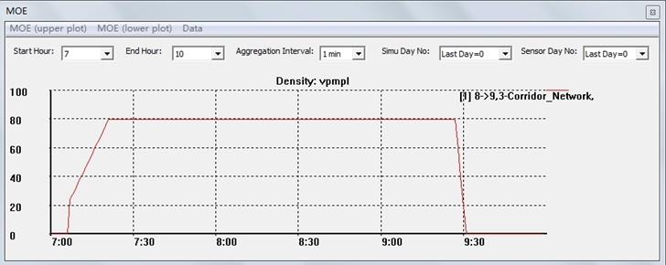

Fig.30. Simulated density of link 8->9

**Problem 5** 

Describe traffic speed and density evolutions on links 7->8 and 8->9. Calculate the traffic congestion speed.

**Hints**: The speed of link 8->9 changes from 60 mph to 15 mph in the first 20 min, and its density increases from 24 vpmpl to 80 vpmpl.

To calculate traffic congestion propagation speed, we need to measure the propagation time and link length (1 mile). First, we need to select two links simultaneously, link 8->9 and link 7->8. Using key combination “ctrl +mouse click”, we can obtain the link MOE plot shown in Fig.31 and then measure the queue propagation time.

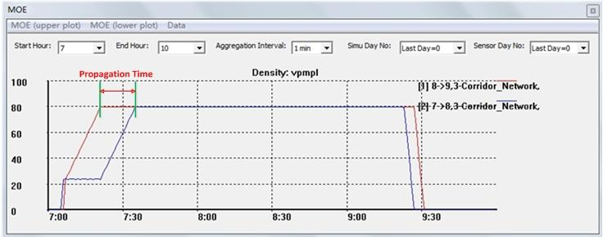

Fig.31. the simulation density of two links, 8->9 and 7->8

One can also precisely measure the exact propagation time duration using exported link MOE csv file. The method for exporting the Link MOE csv is: click the “Export Link MOE to CSV File” of “Data” in the menu bar of MOE dialog.

* When the density (link 8->9) becomes 80, the corresponding time is 441min
* When the density (link 7->8) becomes 80 for, the corresponding time is 455 min.

Thus, the propagation time duration is 14 min.

## (2) Graphical Method

Given an increased demand, the flow-density plot is updated in Fig.32.and the graphical illustration is shown in Fig.33.

|  |  |
| --- | --- |
| Fig.32. The flow-density relationship for different states of links | U: interface between two different traffic states.  State O: there is no traffic flow  State A: the demand traffic enter the link 8->9  State B: the steady traffic state of link 8->9  State C: the steady traffic state of link 9->10 |
| Fig.33. Vehicles’ trajectory in time-space diagram | **Speed:** for link 8->9, at state A, its speed is 60 mph; at state B, due to the limitation of capacity, its speed is 15 mph. For link 9->10, the vehicles will drive at a speed based on the capacity, state C, whose speed is 60 mph;  **Density:** for link 8->9, at the state A, its density is 72 vpmpl(link). After the propagation time, it is at the state B, whose density is 240 vpmpl(link). Meanwhile, the link 9->10 is always at the state C, whose density is 60 vpmpl(link) . In addition, the method of calculating the density of each lane is the same as case 1.  **Propagation time:** 14 min. |

**Problem 6** 

Please compare the results between the simulation method and the graphical method. What is the expected start time for vehicles on link 7->8 seeing traffic congestion?

# **Case3: demand > supply (multiplier = 1.3)**

## (1) DTALite (KW Simulation Model)

In this case, the demand OD is still 7200 from 7am to 9am, and the multiplier is 1.3. The analysis process is the same as case 2.

Select the “Link MOE” of the GIS layer panel -> click the link 8->9. Then show the “speed” and “density” of MOE to analyze the traffic state. For example, when clicking the “speed (mph)”, it is shown in Fig.34; when clicking the “density (vpmpl)”, it is shown in Fig.35.

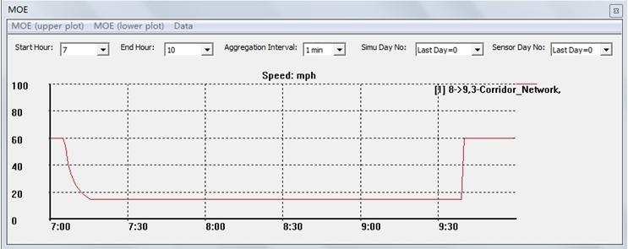

Fig.34. Simulated density of link 8->9

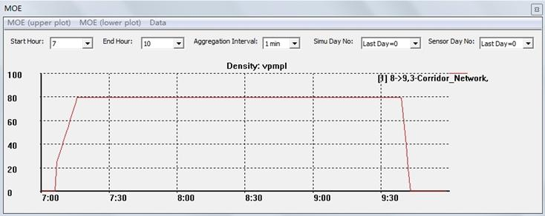

Fig.35 Simulated speed of link 8->9

The speed of link 8->9 changes from 60 mph to 15 mph, and its density of one lane increases from 26 vpmpl to 80 vpmpl. A traffic congestion propagation time of 9 min can be observed in Fig.36.

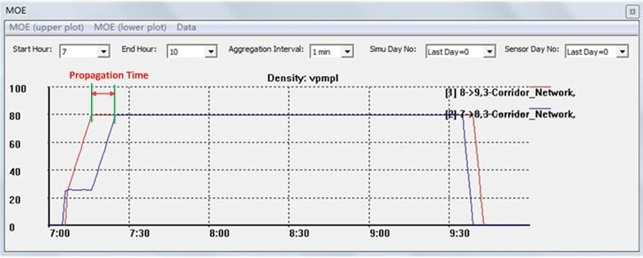

Fig.36. Simulated density of two links, 8->9 and 7->8

## (2) Graphical Method

Given an increased demand, the corresponding flow-density relationship is illustrated in Fig.37 and the graphical illustration is shown in Fig.38.

|  |  |
| --- | --- |
| Fig.37. The flow-density relationship for different states of links | U: interface between two different traffic states.  State O: there is no traffic flow  State A: the demand traffic enter the link 8->9  State B: the steady traffic state of link 8->9  State C: the steady traffic state of link 9->10 |
| Fig.38. Vehicles’ trajectory in time-space diagram | **Speed:** For link 8->9, at state A, its speed is 60 mph; at state B, due to the limitation of capacity, its speed is 15 mph. For link 9->10, the vehicles will drive in a speed based on the capacity, state C, whose speed is 60 mph;  **Density**: For link 8->9, at state A, its density is 78 vpmpl(link). After the propagation time, at state B, its density is 240 vpmpl(link). Meanwhile, the link 9->10 is always at the state C, whose density is 60 vpmpl(link) . In addition, the method of calculating the density of each lane is the same as case 1.  **Propagation time:** 9 min. |

**Problem 7** 

Please compare the results of cases 1, 2 and 3, and plot path 1 travel time in time horizon under three OD demand levels.

**Problem 8** 

In case 3, how much time does it take from traffic congestion propagating from the bottleneck to the origin node? Please calculate the congestion propagation time analytically, and then check your estimated value based on the “density contour” or “speed contour” in NeXTA.

**Recommendations**

*Please share your comments online for improving this document. If you have any questions or encounter any problems, please feel free to contact us (*[*jiangtao.liu@asu.edu*](mailto:jiangtao.liu@asu.edu)*;* [*xzhou74@asu.edu*](mailto:xzhou74@asu.edu)*). Your any feedback is greatly appreciated!*

**Source:**

1) To use NeXTA/DTALite package, please install open-source package **gnuplot** at <http://sourceforge.net/projects/gnuplot/files/> or [http://www.gnuplot.info](http://www.gnuplot.info/) for generating traffic density/speed contour plots. NeXTA will generate gnuplot files (*.plt) to be automatically open and plot by gnuplot.